## Introduction to AWS Cloud:

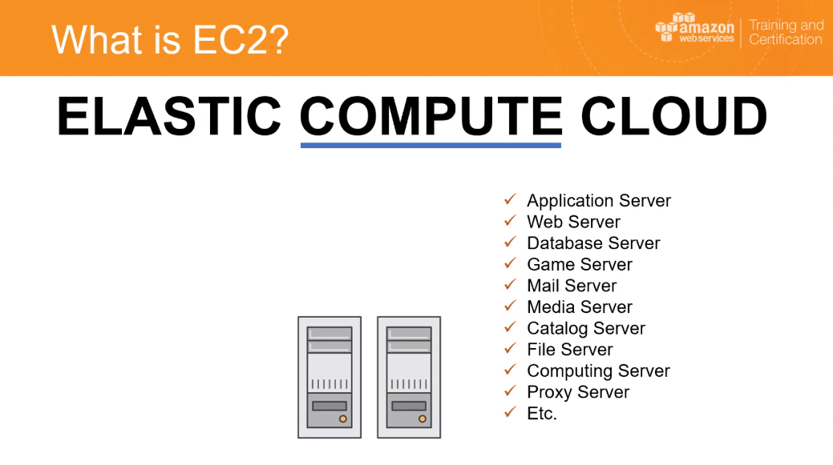

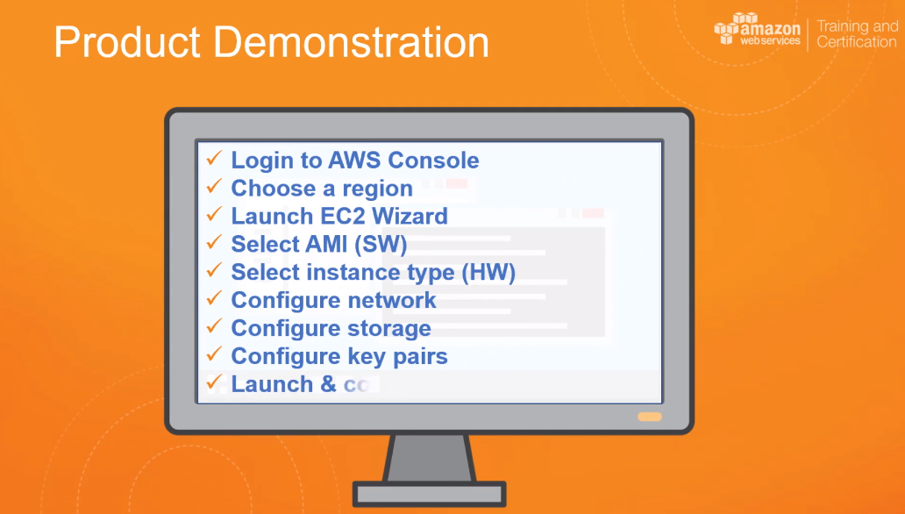

EBS:

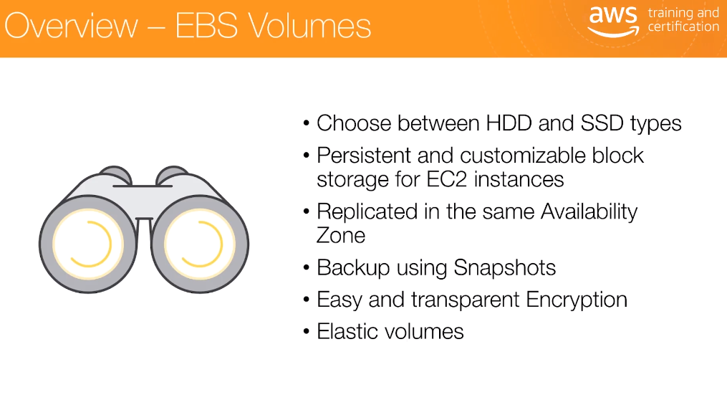

## S3

* We can save DB snapshot
* When we create a S3 bucket, it belongs to the region where we create. But it is redundantly stored across multiple AWS regions.
* Automatically manages the storage of the object
* It handles the high availability of the resources even the number of object grows
* Only billed for what we use

## Access S3:

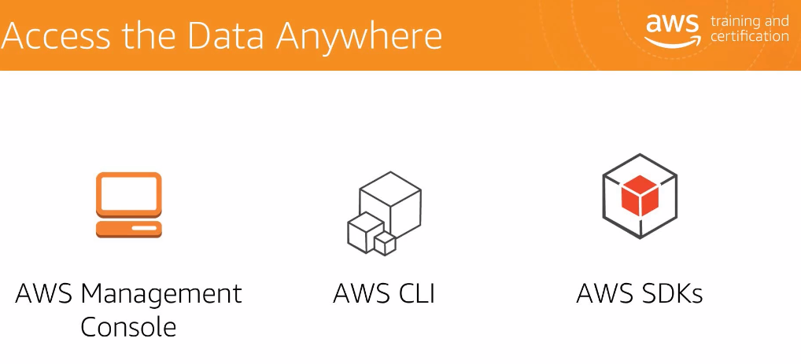

Additionally we can access the data using rest endpoints

